Experiment Name: Implementation of DDA Line Drawing Algorithm

Objective
The objective of this experiment is to implement the Digital Differential Analyzer (DDA) line drawing algorithm to draw a straight line between two given points on a 2D coordinate system using a programming language and graphical visualization.

Theory
The Digital Differential Analyzer (DDA) is a scan conversion algorithm used in computer graphic to draw straight lines.
It works by calculating the incremental values of x and y based on the slope of the line and plotting intermediate points between the starting and ending coordinates.
For two points:
- Starting point: (x1,y1)
- Ending point: (x2,y2)

Program Code
import matplotlib.pyplot as plt

x1 = int(input("Enter x1: "))
y1 = int(input("Enter y1: "))
x2 = int(input("Enter x2: "))
y2 = int(input("Enter y2: "))

dx = x2 - x1
dy = y2 - y1
m=dy/dx

x = x1
y = y1
X = []
Y = []
if dx > dy:
steps = dx
else:
steps = dy
i = 0
while i <= steps:

X.append(round(x))
Y.append(round(y))

if m > 1:
x = x +(1/m)
y = y + 1
elif m < 1:
x = x + 1
y = y + m
else:
x = x + 1
y = y + 1

i = i + 1

plt.plot(X, Y, marker='o')
plt.xlabel("X axis")
plt.ylabel("Y axis")
plt.title("DDA Line Drawing Algorithm")
plt.grid(True)
plt.show()

Output
A straight line is drawn between the points (5, 6) and (8, 12) using the DDA line drawing algorithm.
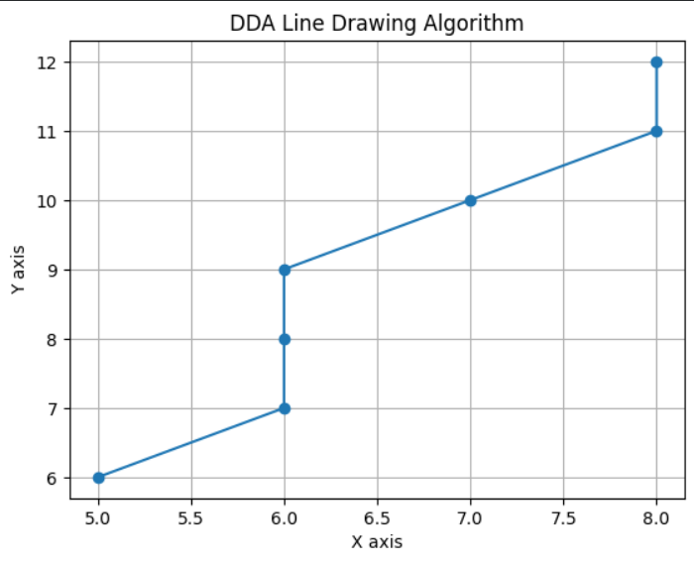

Result
The DDA line drawing algorithm was successfully implemented. The line between two given points was drawn correctly using incremental calculations.

Advantages:
- Simplest line drawing algorithm
- No special skills required for its implementation
- DDA draws the line faster than drawing the line by directly using the line equation
Disadvantages:
- It depends on orientation, which makes the end point accuracy poor.
- It requires floating-point addition to determine each successive point, which is time-consuming.
- Error due to limited precision in floating-point representation may cause calculated points to shift away from their actual position when the line is relatively long.

Conclusion
From this experiment, it can be concluded that the DDA algorithm can effectively draw a straight line between two points using incremental calculations. It is suitable for understanding basic computer graphics concepts.

